Running the Security Content Automation Protocol (SCAP) on a Linux server involves several steps. SCAP is a suite of tools for automating the management of security compliance among systems. Here's a guide to help you get started:

### 1. Install SCAP Tools

First, you need to install the necessary SCAP tools on your Linux server. The most common tool for this purpose is OpenSCAP, an open-source implementation of SCAP. We will be using the DoD version provided by DISA on DoD Cyber Exchange.

* Login to your Linux System using Mobaxterm with the information provided by your instructor.
* Elevate the command prompt
  + #sudo bash
* Navigate to the temp directory
  + #cd /tmp
* Using the wget command pull the version of SCAP needed on the system for running the scans.
  + # wget <https://dl.dod.cyber.mil/wp-content/uploads/stigs/zip/scc-5.8_ubuntu18_ubuntu20_amd64_bundle.zip>
  + 
* Run the ls -lah command in the directory to ensure the zip file has downloaded correctly.
  + #ls -lah
  + 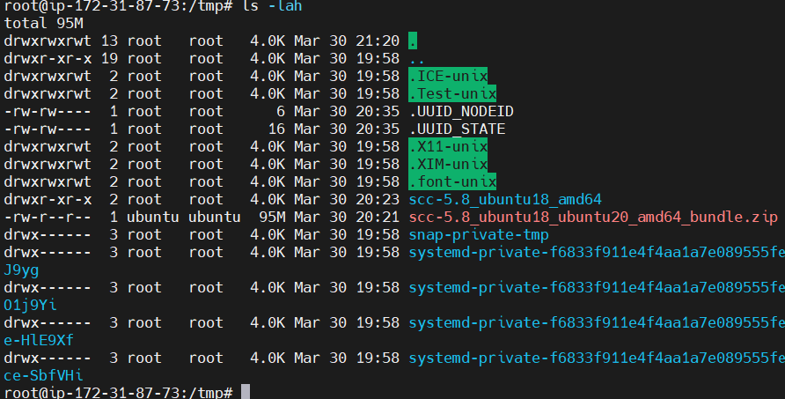
* Now you will need to unzip the download before installing on the server.
  + # unzip scc-5.8_ubuntu18_ubuntu20_amd64_bundle.zip
  + 
* Navigate to the folder using “cd scc-5.8_ubuntu18_amd64”
* To install run “ dpkg -i scc-5.8_ubuntu18_amd64 “
  + 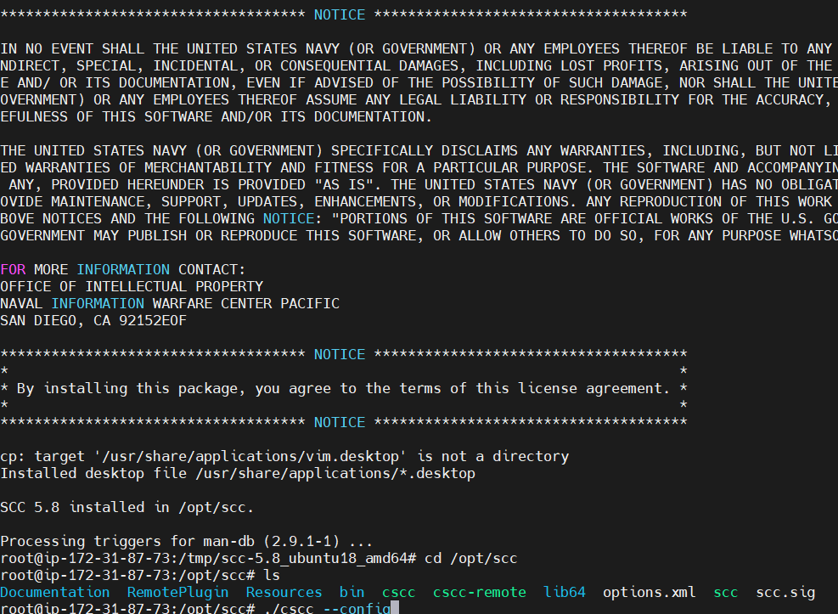

### 2.Run SCAP Scan

With the SCAP tool installed and the appropriate content identified, you're ready to run a scan on your server.

* Perform a compliance scan by navigating to the directory shown in the installation text and run the configuration command. This will allow you to uncheck the scans not applicable to your system.
  + # cd /opt/scc
  + # ./cscc –config
  + 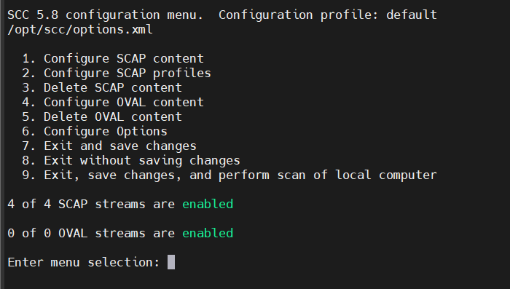
  + Enter “1” for Configure SCAP content menu and press enter
  + Unselect each benchmark that will not be used on the target system by entering the number 1 at a time and pressing enter after each until only the Ubuntu 20 content is selected.
  + 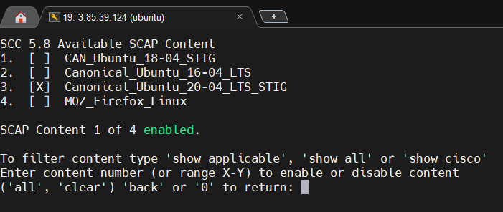
  + Once completed enter “0” to return
  + 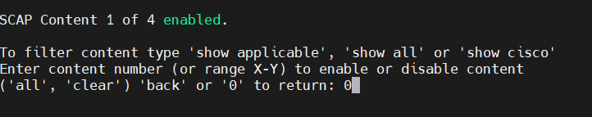
  + One the next screen we will enter “9” so that we save our changes and initiate a scan job.
  + 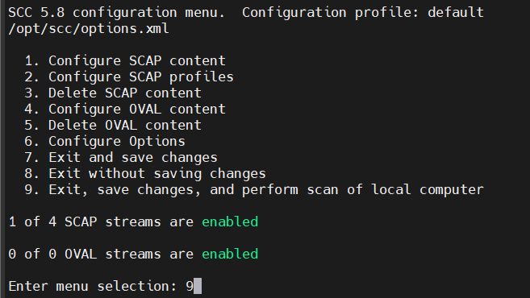
  + 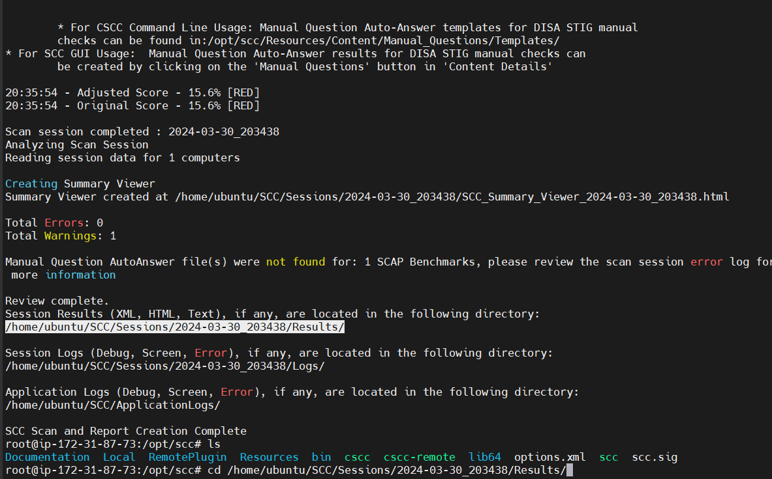

### 4. Review the Results

### **Locate the SCC Scan Results**

* Once connected, you'll need to navigate to the directory where SCC scan results are stored. Typically, these results are located in /home/ubuntu/SCC/Sessions. Use the following command to navigate to this directory:
  + cd /home/ubuntu/SCC/Sessions

### **List the Available Scan Results**

* Before proceeding with the transfer, verify the files you wish to copy. List the contents of the directory:
  + ls -l

### **Transfer Files to Your Local Machine**

Mobaxterm integrates a graphical SFTP (Secure File Transfer Protocol) browser that simplifies the process of transferring files from your Linux server to your local machine.

* Open the SFTP Browser: On the left-hand side of your Mobaxterm window, you'll see the SFTP browser that automatically connects to the server's file system.
* Navigate to the SCC Scan Results: Using the SFTP browser, navigate to /home/ubuntu/SCC/Sessions, where your SCC scan results are located.
* Select the Files to Transfer: Once in the correct directory, you can see your scan result files. Select the files you wish to transfer by clicking on them.
* Copy Files to Your Local Machine: Drag and drop the selected files from the SFTP browser to a folder on your local machine, or right-click on the selected files and choose "Download" to start the transfer process.

### **Step 5: Review the SCC Scan Results**

With the files now on your local machine, you can begin the review process. Depending on the file format of the scan results (often XML or HTML), you can use various tools for review:

* XML Files: XML files can be opened with any text editor, but specialized XML viewers or editors can provide a more structured view.
* HTML Files: HTML files can be opened with any web browser, offering a formatted and easily navigable presentation of the scan results.

### **Conclusion**

Transferring and reviewing SCC scan data using Mobaxterm simplifies the process of maintaining security compliance on your systems. By following the steps outlined in this guide, you can efficiently review SCC scan results to ensure your systems adhere to required security standards.